

DAA Lab Assignment 1


Submitted By:

Name: Siddhant K. Singh
Roll No.: 2301201140
Course: BCA (Sp. In AI & Data Science) Sem- 5th Semester

Lab Assignment – 1

- Merge Sort

Question
Implement Merge Sort. Document input/output, complexity, space usage, suitability, and trade-offs. Profile performance and visualize results.

Solution Input/Output
  - Input: List of numbers
  - Output: Sorted list

Time Complexity

Best | Average | Worst
𝑂(𝑛𝑙𝑜𝑔𝑛) | 𝑂(𝑛𝑙𝑜𝑔𝑛) | 𝑂(𝑛𝑙𝑜𝑔𝑛)
Space Usage
  - 𝑂(𝑛) (temporary arrays for merging)

Suitability & Trade-Offs
  - Excellent for large datasets.
  - Stable sort, predictable performance.
  - Space overhead from extra arrays.

Profiling & Visualization
  - Profile with varying list sizes.
  - Recursive depth is 𝑂(𝑙𝑜𝑔𝑛).

def merge_sort(arr):

if len(arr) <= 1:
return arr
mid = len(arr) // 2
left = merge_sort(arr[:mid]) right = merge_sort(arr[mid:]) merged = []
l = r = 0
while l < len(left) and r < len(right): if left[l] < right[r]:
merged.append(left[l]) l += 1
else:
merged.append(right[r]) r += 1
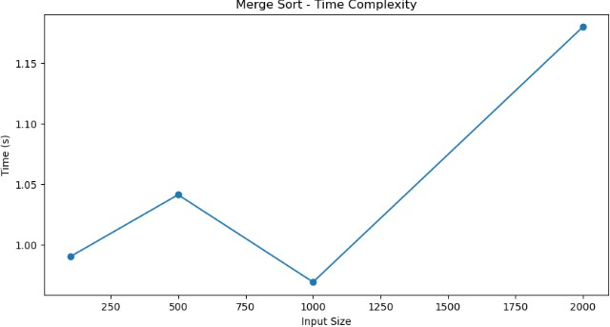
merged.extend(left[l:]) merged.extend(right[r:]) return merged

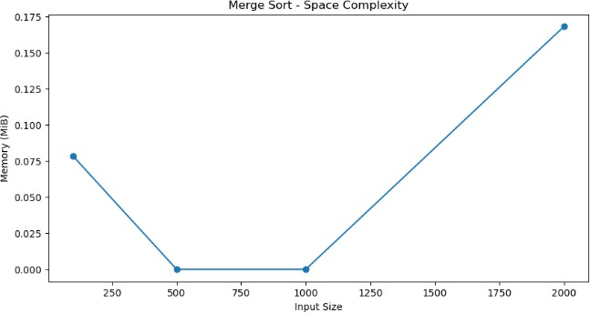

- Quick Sort

Question
Implement Quick Sort. Document input/output, complexity, space usage, suitability, and trade-offs. Profile and visualize.

Solution Input/Output
  - Input: List of numbers
  - Output: Sorted list

Time Complexity

Best | Average | Worst
𝑂(𝑛𝑙𝑜𝑔𝑛) | 𝑂(𝑛𝑙𝑜𝑔𝑛) | 2  𝑂(𝑛 )
Space Usage
  - 𝑂(𝑙𝑜𝑔𝑛) (stack frames, in-place version)

Suitability & Trade-Offs
  - Fast, in-place; not stable.
  - Worst case arises with poor pivot selection.
  - Recursive depth risk in worst case.

Profiling & Visualization

  - Profile across random and sorted data.
  - Stack overflow if recursion is unbalanced.

def quick_sort(arr):
if len(arr) <= 1:
return arr
pivot = arr[len(arr)//2]
left = [x for x in arr if x < pivot] mid = [x for x in arr if x == pivot] right = [x for x in arr if x > pivot]
return quick_sort(left) + mid + quick_sort(right)

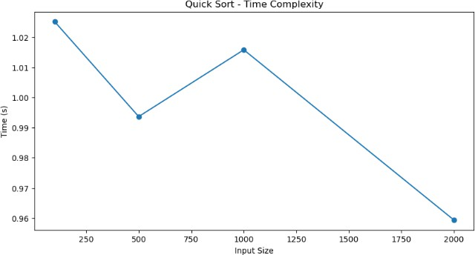

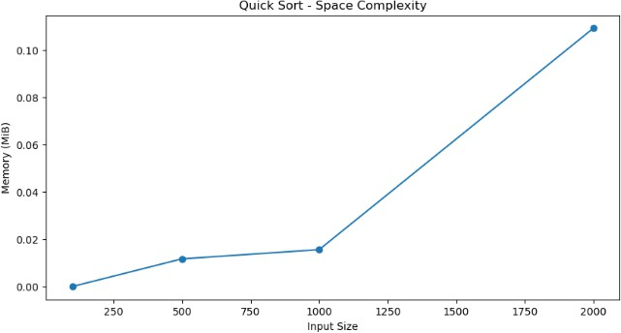

- Insertion Sort

Question
Implement Insertion Sort. Document all aspects as per instructions and provide profiling/visualization.

Solution Input/Output
  - Input: List of numbers
  - Output: Sorted list

Time Complexity

Best | Average | Worst
𝑂(𝑛) | 2  𝑂(𝑛 ) | 2  𝑂(𝑛 )
Space Usage
  - 𝑂(1) (in-place)

Suitability & Trade-Offs
  - Suitable for small data and nearly sorted lists.

  - Simple, little overhead, but slow for large datasets.
  - No recursion risk.

Profiling & Visualization
  - Time grows quickly for large lists.

Code
python
def insertion_sort(arr):
for i in range(1, len(arr)): key = arr[i]
j = i - 1
while j >= 0 and arr[j] > key: arr[j+1] = arr[j]
j -= 1
arr[j+1] = key
return arr

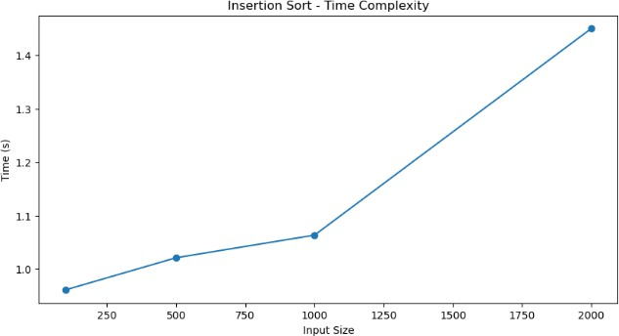

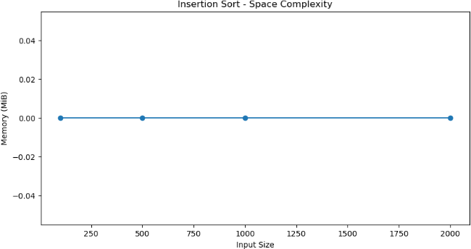

- Bubble Sort

Question
Implement Bubble Sort, document, profile, and plot results.

Solution Input/Output
  - Input: List of numbers
  - Output: Sorted list

Time Complexity

Best | Average | Worst
𝑂(𝑛) | 2  𝑂(𝑛 ) | 2  𝑂(𝑛 )
Space Usage
  - 𝑂(1) (in-place)

Suitability & Trade-Offs
  - Educational only, not practical for large datasets.
  - Simple, but very inefficient for most cases.
  - No recursion risk.

Profiling & Visualization
  - Used as baseline for sorting comparisons.

Code
python
def bubble_sort(arr):
n = len(arr)
for i in range(n):
for j in range(0, n-i-1):
if arr[j] > arr[j+1]:
arr[j], arr[j+1] = arr[j+1], arr[j]
return arr

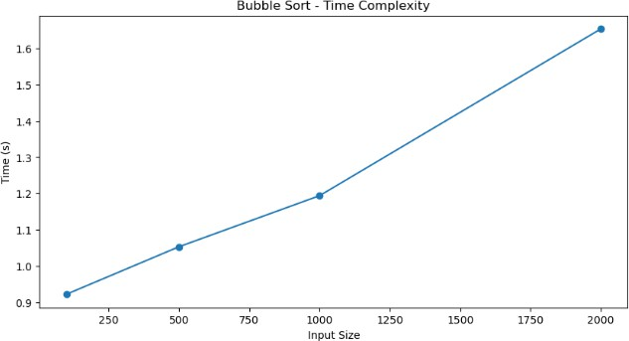

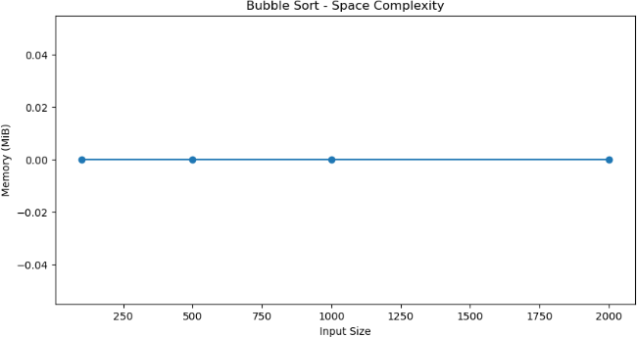

- Selection Sort

Question
Implement Selection Sort. Include documentation and profiling.

Solution Input/Output
  - Input: List of numbers
  - Output: Sorted list

Time Complexity

Best | Average | Worst
2  𝑂(𝑛 ) | 2  𝑂(𝑛 ) | 2  𝑂(𝑛 )
Space Usage
  - 𝑂(1) (in-place)

Suitability & Trade-Offs
  - Simple, but slow for large datasets.
  - No recursion risk.

  - Good for small lists.

Profiling & Visualization
  - Tends to be slower than insertion sort for most cases.

Code
python
def selection_sort(arr):
n = len(arr)
for i in range(n):
min_idx = i
for j in range(i+1, n):
if arr[j] < arr[min_idx]: min_idx = j
arr[i], arr[min_idx] = arr[min_idx], arr[i]
return arr

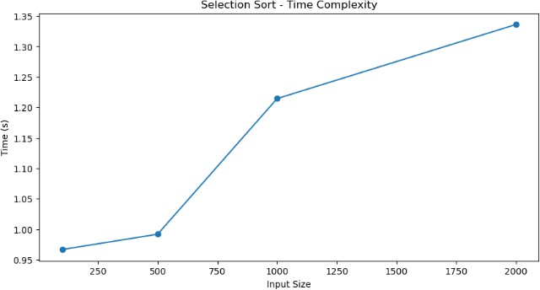

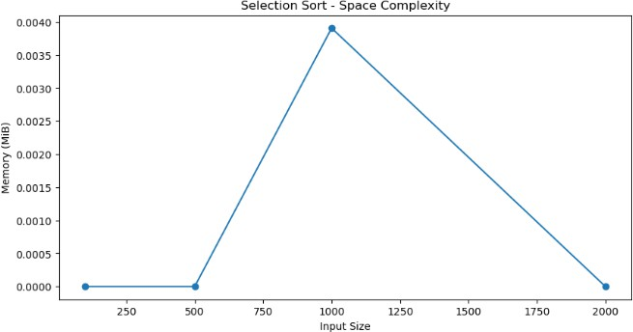

- Fibonacci (Dynamic Programming) Input: A number n
Output: nth Fibonacci number Time Complexity: O(n)
Space Complexity: O(n) (can be optimized to O(1)) Much faster and scalable than recursive.

- Fibonacci (Recursive) Input: A number n
Output: nth Fibonacci number
Time Complexity: Exponential O(2^n) Space Complexity: O(n) (recursion stack)
Suitable only for very small inputs. Risk of stack overflow if n is large.

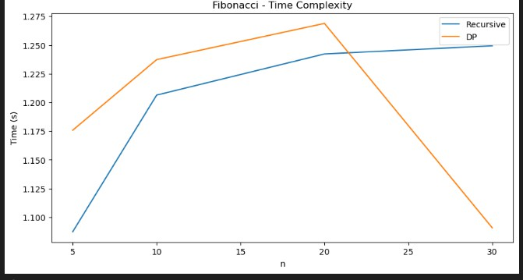

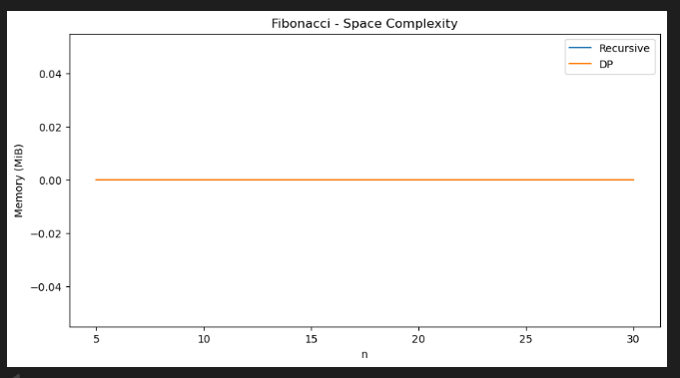

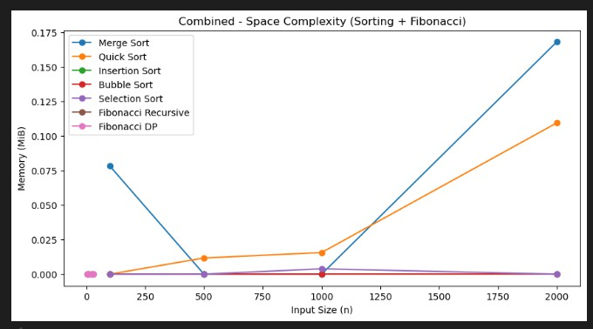
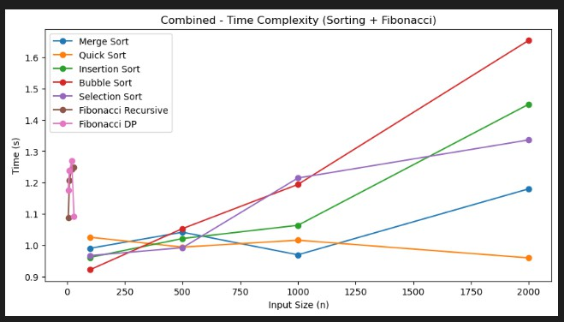

GitHub: https://github.com/BluntPhoenix04/Daa-Lab_Assignment/Lab_Assignment-1

